LAB 1: Write HTML code to design a page containing some text in a paragraph by giving suitable heading style and some text formatting tags. Also use semantic markup (citation, abbreviation, quotation, strong & emphasis).

<!DOCTYPE html>

<html lang="en">

  <head>

    <meta charset="UTF-8" />

    <meta name="viewport" content="width=device-width, initial-scale=1.0" />

    <title>LAB 1 WEB</title>

  </head>

  <body>

    <h1>This is NewYork</h1>

    <h2>This is America</h2>

    <strong style="color: palevioletred">Your dad is president of USA</strong>

    <p>America's goal is to:<q>Get all the oil of the world</q></p>

    <hr />

    <article>

      <h2>Fat People</h2>

      <p>Over 90% citizens in america is fat</p>

    </article>

    <article>

      <h2>Mass Shooting</h2>

      <p>America is home for crime too</p>

    </article>

    <article>

      <h2>Me</h2>

      <p>I still go to america <sub>xd</sub></p>

      <p>I drink H<sup>2</sup>o</p>

    </article>

    <hr />

  </body>

  <em>Heheheheeh Boiii</em>

  <p>&copy;Made by Samrajya Dai</p>

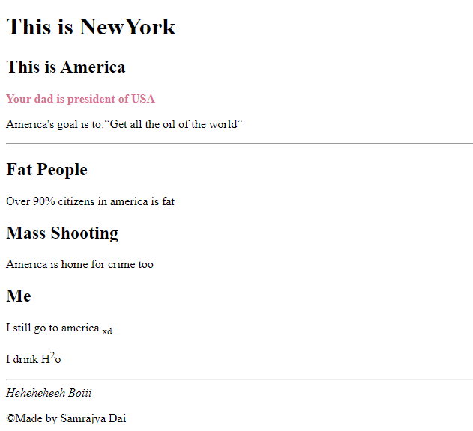</html>